trapping exceptions:

1.The followingPL/SQLprogram will encounter an error reflecting a violation of a uniqueness constraint. Run the program and examine the resulting error message.

Q: What was the error message you recceived?

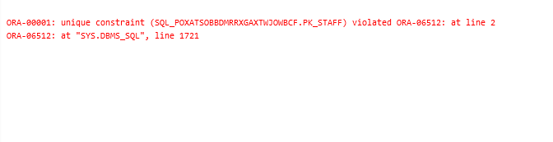

BEGIN

INSERT INTO STAFF (ENAME, ETITLE, ESALARY, DEPT)

VALUES ('MARK', 'LAB ASSIST', 1000, 'MGT');

END;

Q: What did the query return? (Show the output)

SELECT CONSTRAINT_TYPE, TABLE_NAME, SEARCH_CONDITION,

INDEX_NAME

FROM USER_CONSTRAINTS

WHERE CONSTRAINT_NAME = ‘SQL_ZMSTSWTIOCCIHIZJYVWTWPFVQ.PK_STAFF’;

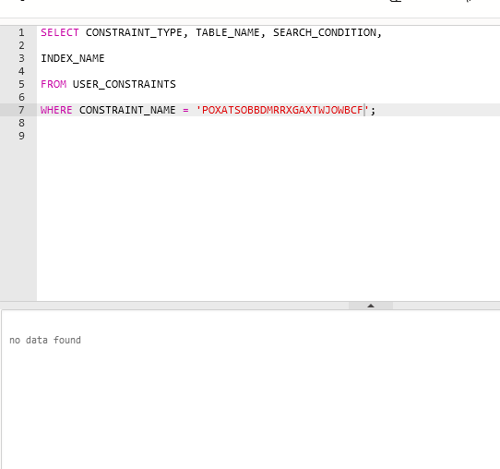

Q: What is the name of the column for this index?(Show the outputof the query)

SELECT I.INDEX_NAME, I.UNIQUENESS, C.COLUMN_NAME,C

.COLUMN_POSITION

FROM USER_INDEXES I, USER_IND_COLUMNS C

WHERE I.TABLE_NAME = 'STAFF'AND I.INDEX_NAME = C.INDEX_NAME

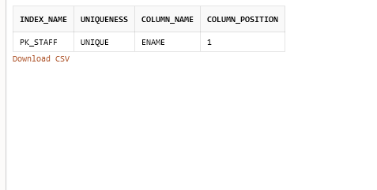

pk STAFF

BEGIN

INSERT INTO STAFF (ENAME, ETITLE, ESALARY, DEPT)

VALUES ('MARK', 'LAB ASSIST', 1000, 'MGT');

EXCEPTION

WHEN DUP_VAL_ON_INDEX THEN

DBMS_OUTPUT.PUT_LINE('DUPLICATE INDEX VALUE');

DBMS_OUTPUT.PUT_LINE(SQLCODE);

DBMS_OUTPUT.PUT_LINE(SQLERRM);

END;

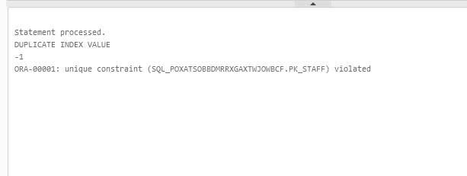

DECLARE

CURSOR C1 (D STAFF.DEPT%TYPE) IS

SELECT ENAME

FROM STAFF

WHERE DEPT = D;

ENAME VARCHAR2(9);

BEGIN

OPEN C1 ('THEO');

LOOP

FETCH C1 INTO ENAME;

EXIT WHEN C1%NOTFOUND;

DBMS_OUTPUT.PUT_LINE(ENAME);

END LOOP;

END;

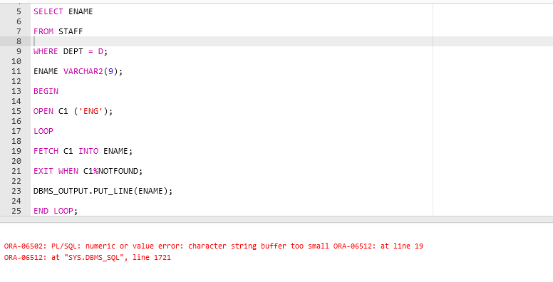

What is the problem identified in the error message?(Be precise! Do not simply show the error message –explain the actual problem.

The error is a value error which is An arithmetic, conversion, truncation, or size-constraint error occurs.

DECLARE

CURSOR C1 (D STAFF.DEPT%TYPE) IS

SELECT ENAME

FROM STAFF

WHERE DEPT = D;

ENAME VARCHAR2(9);

BEGIN OPEN C1 ('THEO');

LOOP FETCH C1 INTO ENAME;

EXIT WHEN C1%NOTFOUND;

DBMS_OUTPUT.PUT_LINE(ENAME);

END LOOP;

END;

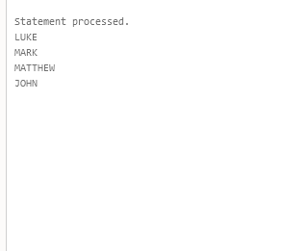

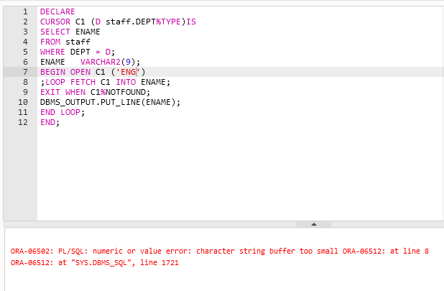

DECLARE

CURSOR C1 (D staff.DEPT%TYPE)IS

SELECT ENAME

FROM staff

WHERE DEPT = D;

ENAME VARCHAR2(9);

BEGIN OPEN C1 ('ENG')

;LOOP FETCH C1 INTO ENAME;

EXIT WHEN C1%NOTFOUND;

DBMS_OUTPUT.PUT_LINE(ENAME);

END LOOP;

END;

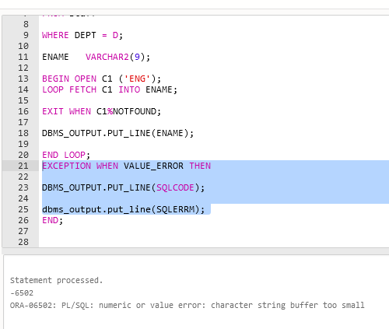

Q: What is the problem identified in the error message?(Be precise!Do not simply show the error message –explain the actual problem.)

THE problem identified in the error message is that the character string is not big enough to output.

Modify the program again:

DECLARE

CURSOR C1 (D STAFF.DEPT%TYPE) IS

SELECT ENAME

FROM STAFF

WHERE DEPT = D;

ENAME NUMBER;

BEGIN

OPEN C1 ('THEO');

LOOP FETCH C1 INTO ENAME;

END LOOP;

END;

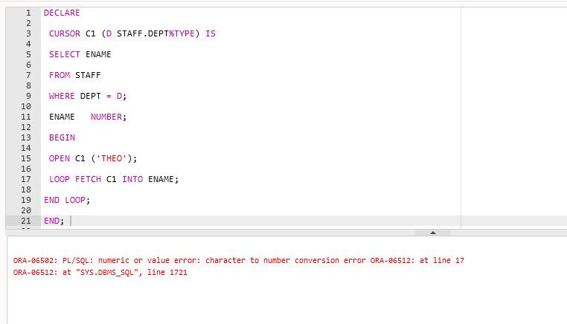

DECLARE

CURSOR C1 (D STAFF.DEPT%TYPE) IS

SELECT ENAME

FROM STAFF

WHERE DEPT = D;

ENAME NUMBER;

BEGIN

OPEN C1 ('THEO');

LOOP FETCH C1 INTO ENAME;

END LOOP;

EXCEPTION WHEN VALUE_ERROR THEN

DBMS_OUTPUT.PUT_LINE(SQLCODE);

dbms_output.put_line(SQLERRM);

END;

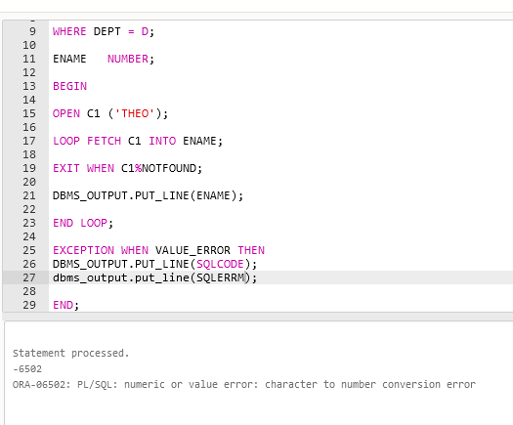

EXCEPTION WHEN VALUE_ERROR THEN

DBMS_OUTPUT.PUT_LINE(SQLCODE);

dbms_output.put_line(SQLERRM);

Question 3:

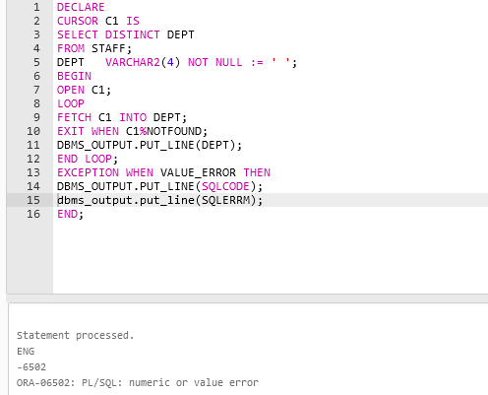

The department string is too small for rows other than END.

The program can output the rows that did not trigger the exception handler can be found in my output. Putting the exception handler at the end allows my program to run the loop until it is triggered.